Joel Atkinson

June 10,2025

Assignment 3.2

Database Development & Use

Embedded Excel File:

Screenshots:

1. Assignment details and Legend

2: 1NF Table:

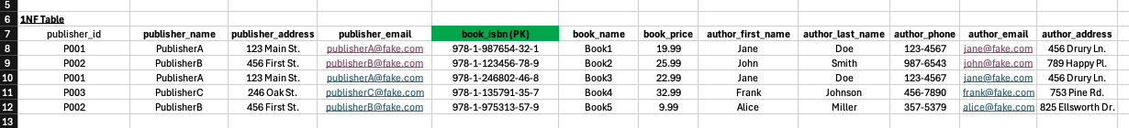

3: 3NF Tables:

Assumptions I made while creating these tables:

* There was only one author per book
* I was not really sure what an ISBN was before this assignment so I had to research that and assumed that there is only one unique ISBN per book
* There was only one publisher per book
* I assumed that the data was up to date and did not have any historical changes for things like addresses and phone numbers